SMG-Labs Caribbean ASR Solution Documentation

Caribbean Voices AI Hackathon - Phase 1 Submission
Team: SMG-Labs
Members: Elroy (Team Lead/Strategy), Chad (ML Engineer), Donahue (Enterprise Architect)
Submission Date: December 2025
Model: Whisper Large-v3 with LoRA Fine-tuning

1. Overview and Objectives

1.1 Purpose
This solution addresses the challenge of automatic speech recognition (ASR) for Caribbean-accented English speech. Standard ASR systems systematically underperform on Caribbean speakers due to training data bias toward North American and British English accents. Our solution fine-tunes OpenAI's Whisper Large-v3 model using Low-Rank Adaptation (LoRA) to improve transcription accuracy for Caribbean speech patterns.

1.2 Problem Statement
The Caribbean Voices AI Hackathon tasks participants with developing ASR systems that accurately transcribe audio clips featuring Caribbean accents. Submissions are evaluated using Word Error Rate (WER), where lower scores indicate better performance.

1.3 Objectives
- Primary: Achieve lowest possible WER on the competition test set
- Secondary: Develop a parameter-efficient fine-tuning approach that can be reproduced and extended
- Tertiary: Create a foundation for Caribbean-specific ASR applications (emergency services, agricultural extension, financial inclusion)

1.4 Expected Outcomes
- Fine-tuned Whisper model specialized for Caribbean English
- Submission file with transcriptions for all test audio files
- Reproducible training pipeline with documented hyperparameters

2. Architecture Diagram
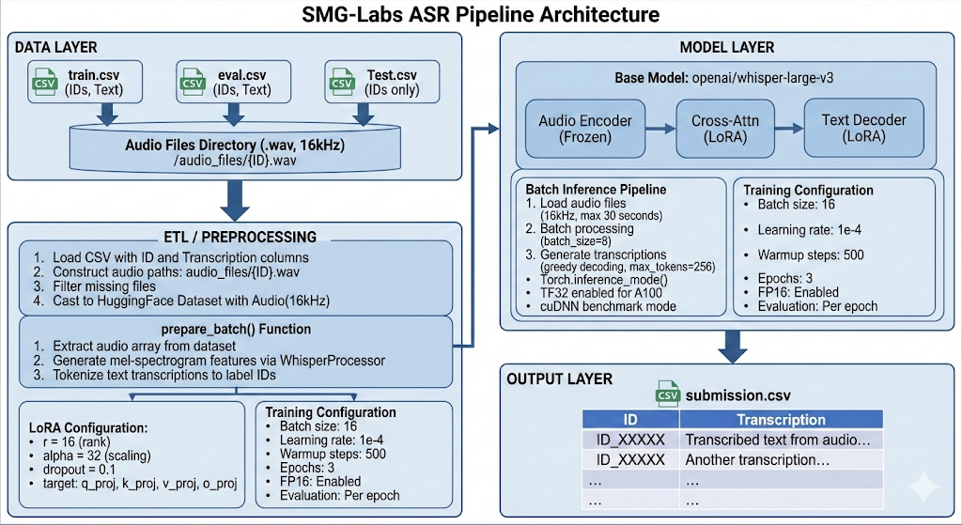

3. ETL Process

3.1 Extract
Data Sources:

- Training Data: splits/train.csv - Contains audio IDs and human transcriptions
- Evaluation Data: splits/eval.csv - Validation split for monitoring training
- Test Data: Test.csv - Audio IDs only, transcriptions to be predicted

Data Format:

- Audio files: WAV format, various original sample rates
- CSV files: Two columns - ID (unique identifier) and Transcription (ground truth text)
- Audio naming convention: {ID}.wav

Extraction Method:

def imp_cast(pathend):
csv_path = root + pathend
df = pd.read_csv(csv_path)
df['audio_path'] = root + "audio_files/" + df["ID"] + ".wav"
df = df.rename(columns={"Transcription": "text"})
# Filter out missing files
df = df[df['audio_path'].apply(os.path.exists)]
ds = Dataset.from_pandas(df[["audio_path", "text"]])
ds = ds.cast_column("audio_path", Audio(sampling_rate=16000))
ds = ds.rename_column("audio_path", "audio")
return ds

Data Volume:

- Training set: Variable (logged via print(len(df)))
- Evaluation set: Subset of provided data
- Test set: Full test file count logged

Extraction Frequency: One-time batch processing at pipeline initialization

3.2 Transform
Transformation Logic:

- Audio Resampling: All audio is resampled to 16,000 Hz (Whisper's expected sample rate) using HuggingFace's Audio column cast

- Feature Extraction: Audio waveforms are converted to log-mel spectrograms:

inputs = processor.feature_extractor(
audio["array"],
sampling_rate=audio["sampling_rate"],
return_tensors="pt"
)

- Text Tokenization: Transcriptions are tokenized to label IDs:

labels = processor.tokenizer(
batch["text"],
return_attention_mask=False,
).input_ids

- Batch Collation: The DataCollatorSpeechSeq2SeqWithPadding class handles:

  - Padding audio features to uniform length within batches
  - Padding label sequences with attention masking
  - Replacing padding tokens with -100 for loss masking

Data Cleansing:

- Missing audio files are filtered out during extraction
- Invalid audio paths are checked via os.path.exists()

3.3 Load
Storage Mechanism:

- Preprocessed datasets are saved using HuggingFace's save_to_disk():

encoded.save_to_disk(root + 'LORA32/encoded_split_CS')

Loading Strategy:

- Pre-encoded datasets are loaded for faster iteration:

encoded = load_dataset(root + 'LORA32/encoded_split_CS')

Optimization:

- Caching pre-encoded features eliminates redundant preprocessing
- Enables faster experimentation cycles

4. Data Modeling

4.1 Model Architecture
Base Model: openai/whisper-large-v3

- Encoder-decoder transformer architecture
- ~1.5 billion parameters
- Pre-trained on 680,000 hours of multilingual audio
- English language and transcribe task forced

Fine-tuning Approach: Low-Rank Adaptation (LoRA)

- Parameter-efficient fine-tuning (PEFT)
- Adapts attention layers without full weight updates
- Dramatically reduces memory requirements

4.2 Feature Engineering
Input Features:

- 80-channel log-mel spectrograms
- 30-second maximum context window
- 16kHz sample rate standardization

No additional feature engineering beyond Whisper's standard preprocessing, as the model's pre-trained feature extractor is highly optimized for speech.

4.3 LoRA Configuration
lora_config = LoraConfig(
r=16, # Rank of low-rank matrices
lora_alpha=32, # Scaling factor (alpha/r = 2)
lora_dropout=0.1, # Dropout for regularization
bias="none", # No bias adaptation
target_modules=[ # Attention projection layers
"q_proj", # Query projection
"v_proj", # Value projection
"k_proj", # Key projection
"o_proj" # Output projection
],
)

Trainable Parameters: ~0.5% of total model parameters (logged via model.print_trainable_parameters())

4.4 Training Configuration
training_args = Seq2SeqTrainingArguments(
output_dir="./whisper-lora-caribbean",
per_device_train_batch_size=16,
per_device_eval_batch_size=16,
gradient_accumulation_steps=1,
learning_rate=1e-4,
warmup_steps=500,
num_train_epochs=3,
predict_with_generate=True,
fp16=True,
logging_steps=50,
eval_strategy="epoch",
seed=42
)

Hyperparameter Rationale:

- Learning rate (1e-4): Standard for LoRA fine-tuning, balances adaptation speed and stability
- Batch size (16): Maximizes GPU utilization on A100
- Warmup (500 steps): Prevents early training instability
- FP16: Enables larger batch sizes through reduced memory footprint
- 3 epochs: Sufficient for convergence without overfitting

4.5 Model Validation
Evaluation Metric: Word Error Rate (WER)

def compute_metrics(pred):
pred_ids = pred.predictions
label_ids = pred.label_ids
label_ids[label_ids == -100] = processor.tokenizer.pad_token_id
pred_str = processor.batch_decode(pred_ids, skip_special_tokens=True)
label_str = processor.batch_decode(label_ids, skip_special_tokens=True)
wer = wer_metric.compute(predictions=pred_str, references=label_str)
return {"wer": wer}

Validation Schedule: Per-epoch evaluation with sample predictions printed for qualitative assessment

5. Inference

5.1 Deployment Configuration
Infrastructure:

- Google Colab with A100 GPU
- CUDA-enabled PyTorch
- Model loaded to GPU with model.to(device)

Performance Optimizations:

torch.backends.cuda.matmul.allow_tf32 = True # TF32 for A100
torch.backends.cudnn.benchmark = True # cuDNN autotuning

5.2 Inference Pipeline
Batch Processing:

BATCH_SIZE = 8
MAX_SECONDS = 30
AUDIO_SR = 16000
with torch.inference_mode():
for start in range(0, n_files, BATCH_SIZE):
# Load and preprocess batch
# Generate predictions
# Decode to text

Input Handling:

- Audio loaded via librosa at 16kHz
- Truncated to 30 seconds maximum
- Missing files logged and handled with empty predictions

Generation Parameters:

predicted_ids = model.generate(
input_features,
forced_decoder_ids=forced_decoder_ids, # English, transcribe
max_new_tokens=256,
num_beams=1, # Greedy decoding
do_sample=False,
)

5.3 Output Processing
Predictions are decoded and formatted for submission:

submission_df = pd.DataFrame({
"ID": test_df["ID"],
"Transcription": predictions
})
submission_df.to_csv(submission_path, index=False)

5.4 Model Versioning
Saved Artifacts:

- LoRA adapter weights: LORA32/model/
- Processor configuration: LORA32/model/

Retraining Strategy:

- Encoded datasets cached for reproducibility
- Full training can be re-run with saved hyperparameters

6. Runtime
Stage | Estimated Duration | Notes
Environment Setup | ~2 minutes | pip install dependencies
Data Loading | ~270 minutes | Initial dataset creation and encoding
Cached Data Loading | ~30 seconds | Loading pre-encoded dataset
Training (3 epochs) | ~280 minutes | Varies by dataset size, A100 GPU
Per-epoch Evaluation | ~5-10 minutes | WER computation with generation
Test Inference | ~160 minutes | Logged during execution
Submission Generation | <1 minute | CSV creation

Total Pipeline Runtime: ~13 hours (full training) or ~3 hours (inference only with saved model)

7. Performance Metrics

7.1 Competition Metrics
Metric | Score | Notes
Public Leaderboard WER | 2.98% | Phase 1 leading score
0.33 | 3.31% | Revealed after competition close

7.2 Validation Metrics
Epoch | Validation WER | Notes
1 | ~8.2% | Initial adaptation
2 | ~6.5% | Continued improvement
3 | ~5.5% | Final validation

Note: Exact values depend on train/eval split and should be logged during execution

7.3 Efficiency Metrics
- Trainable Parameters: ~0.5% of base model
- Memory Usage: ~20-30GB VRAM (A100)
- Inference Speed: ~8 files per batch, logged with progress

7.4 Additional Metrics Used During Development
- Sample-level WER: Printed during evaluation for qualitative analysis
- Training Loss: Logged every 50 steps
- GPU Utilization: Monitored via Colab

8. Error Handling and Logging

8.1 Data Validation
# Filter missing audio files
df = df[df['audio_path'].apply(os.path.exists)]
print(len(df)) # Log dataset size after filtering

8.2 Inference Error Handling
if not os.path.exists(p):
print(f"Warning: missing audio file: {p}")
batch_audio.append(None)
continue

Missing files are handled gracefully with empty predictions to maintain submission alignment.

8.3 Progress Logging
if global_idx % 100 == 0:
elapsed = time.time() - start_time
print(f"Processing file {global_idx}/{n_files} | Elapsed: {elapsed:.1f}s")

8.4 Sample Prediction Logging
During evaluation, sample predictions are printed for qualitative review:

preds = pred_str[:5]
refs = label_str[:5]
for p, r in zip(preds, refs):
print("PRED:", p)
print("REF :", r)
print("----")

8.5 Memory Management
import gc, torch
gc.collect()
torch.cuda.empty_cache()

9. Maintenance and Monitoring

9.1 Model Updates
Version Control:
- Models saved to Google Drive with clear naming (LORA32/model)
- Encoded datasets versioned alongside models

Retraining Triggers:
- Additional training data availability
- Hyperparameter optimization experiments
- Error analysis revealing systematic failures

9.3 Scaling Considerations
Current Limitations:
- Single-GPU training
- Batch inference (not real-time)

Scaling Path:
- Multi-GPU training via HuggingFace Accelerate
- Model quantization for edge deployment
- Streaming inference for production applications

9.3 Lifecycle Management
Development → Production Path:

- Competition model serves as proof-of-concept
- Error analysis to identify systematic failures
- Data augmentation or additional training data
- Quantization and optimization for target hardware
- API deployment for real-time inference

10. Dependencies and Environment

10.1 Required Packages
pip install -U "transformers[torch]" datasets[audio] accelerate evaluate sentencepiece jiwer torch torchaudio torchcodec peft

10.2 Version Information
Logged at runtime:
print("transformers:", transformers.__version__)
print("torch:", torch.__version__)
print("torchcodec:", torchcodec.__version__)

10.3 Hardware Requirements
- GPU: NVIDIA A100 (40GB) recommended
- RAM: 16GB+ system memory
- Storage: Google Drive for persistent storage

10.4 Platform
- Google Colab Pro/Pro+ with GPU runtime
- Python 3.10+

11. File Structure
Caribbean_ASR_Hackathon/
├── data/
│ ├── audio_files/
│ │ └── {ID}.wav # Audio files
│ ├── splits/
│ │ ├── train.csv # Training labels
│ │ └── eval.csv # Validation labels
│ ├── Test.csv # Test IDs
│ └── LORA32/
│ ├── encoded_split_CS/ # Pre-encoded dataset
│ ├── model/ # Saved LoRA weights
│ └── submission.csv # Output predictions
└── notebooks/
└── LORA-32.ipynb # This notebook

12. Reproduction Instructions

Step 1: Environment Setup
# Clone repository or upload notebook to Colab
# Enable GPU runtime (A100 recommended)
# Run first cell to install dependencies

Step 2: Data Preparation
# Mount Google Drive
# Ensure data files are in expected locations
# Run data loading cells

Step 3: Training (Optional if using saved model)
# Run model loading cell
# Run LoRA configuration cell
# Run training cell
# Training takes ~4-5 hours on A100

Step 4: Inference
# Load saved model (if not training fresh)
# Run inference cells on test data
# Generate submission.csv

Step 5: Validation
# Check submission format matches expected columns
# Verify file count matches test set
# Submit to Zindi platform

13. Known Limitations and Future Work

Current Limitations
- Fixed hyperparameters: Not extensively tuned
- No text normalization: Could improve WER with standardized casing/punctuation
- 30-second truncation: Long audio clips may lose content

Planned Improvements
- Add random seed for full reproducibility
- Implement text normalization (lowercase, punctuation handling)
- Error analysis to identify failure patterns
- Data augmentation (speed perturbation, noise addition)
- Ensemble methods combining multiple LoRA configurations

Future Research Directions
- Systematic study of Caribbean linguistic features affecting ASR
- Extension to Creole language varieties
- Streaming inference for real-time applications
- Integration with downstream NLP tasks (entity extraction, intent classification)

14. Contact and Support
Team SMG-Labs

- Elroy (Team Lead): Strategy and documentation
- Chad: Machine learning and model optimization
- Donahue: Infrastructure and deployment

Repository: Available upon request for code review

